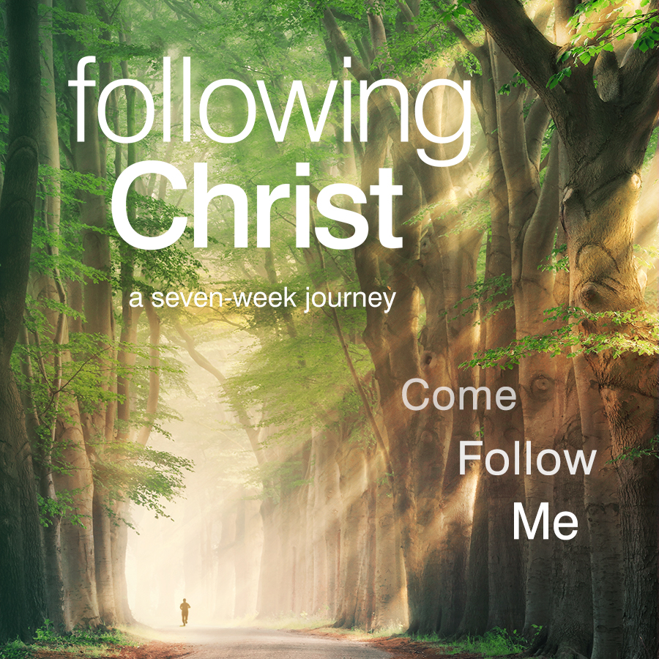

*Following CHRIST*

**SPRING 2025 COURSE SCHEDULE**

Evening Sessions: 7:00-8:45 PM

St. Rose of Lima Parish Center

425 Pennsylvania Avenue, North Wales, PA

267-272-9108

**____________________________________________________________________________________________________________**

**DATE SESSION TOPIC**

**Wednesday, April 23 1 Talk 1 - Daily Personal Prayer**

**Wednesday, April 30 2 Talk 2 - Hearing God in Scripture**

**Wednesday, May 7 3 Talk 3 - The Power of the Sacraments**

**Wednesday, May 14 4 Talk 4 - Forgiving One Another**

**Wednesday, May 21 5 Talk 5 - The Spirit-Empowered Life**

**Wednesday, May 28 No Get Together Memorial Day Break**

**Saturday, May 31 RETREAT We Are at War**

***9:00 AM – 2:45 PM* Talk 6 - The World**

**Talk 7 - The Flesh**

**Talk 8 - The Devil**

**Wednesday, June 4  6 Talk 9- The Heart of A Disciple**

**Wednesday, June 11 7 Talk 10 – Going On With The Lord**